Time Entry – Student Time Entry: Entering Terminated or Inactive Status for Students
- Students can be terminated or inactivated one of two ways.
- One way to terminate or inactivate a student is to submit the information on the underhours report that is sent to the department on a periodic basis from Student Employment Services
- Another way is to Use the STUDENT EMPLOYMENT TERMINATION/ INACTIVATION form.
- The completion and submission of the STUDENT EMPLOYMENT TERMINATION/ INACTIVATION Form by the Department is described below.
- This form is available on line through the Central Electronic Forms Library. To access the Electronic Forms Library, use the following web address:
- http://eforms.siu.edu
- The web page shown below will display.
- Locate the second bullet under the first paragraph, which reads:
- To locate an e-Form to use, Click Here.
- Click on the linked text, Click Here.

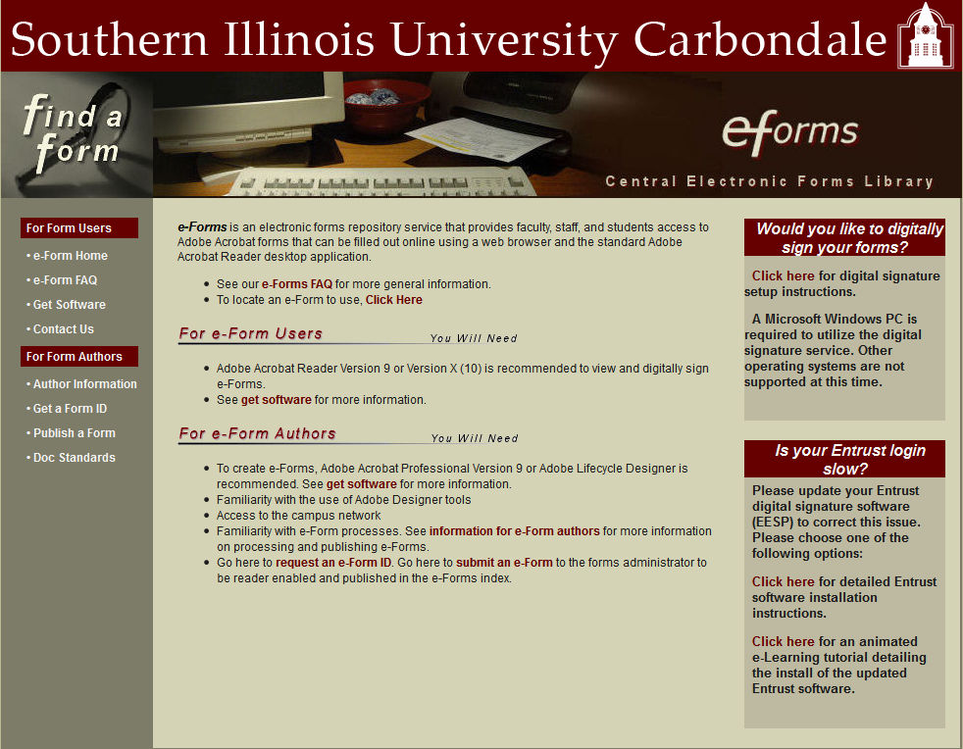

- The search window below opens. Using the Keyword Search field, enter “Student Employment”.
- Click the Search button.
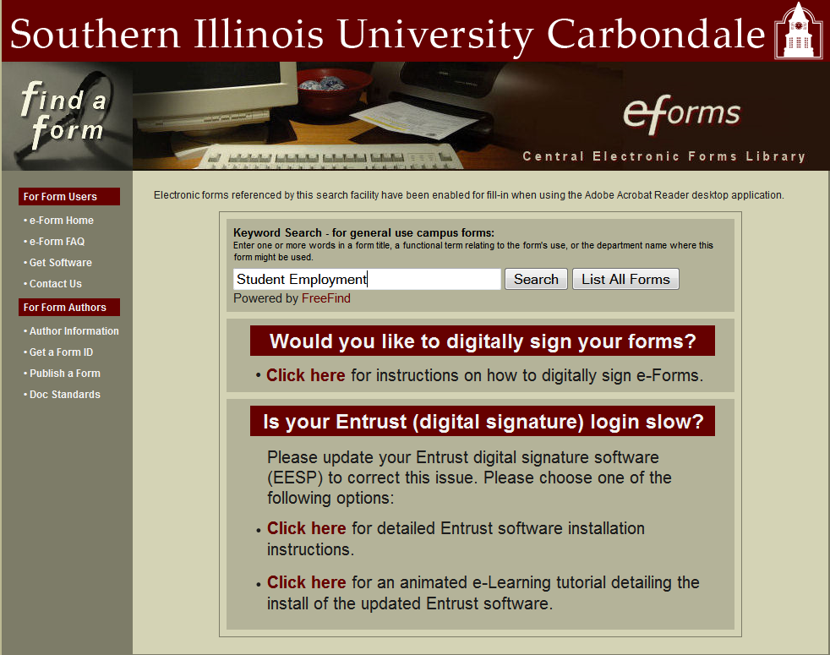
- The Search Results from the Electronic Forms Library are displayed, as shown below.
- Click on the link entitled, Student Employment Termination Inactivation, #2 in the list below.
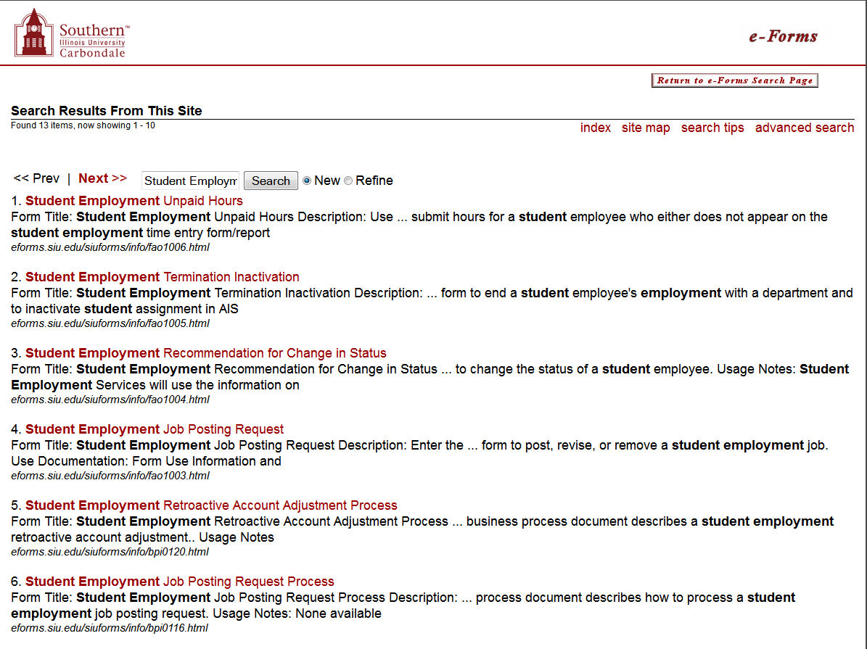

- Click the Download Form button.
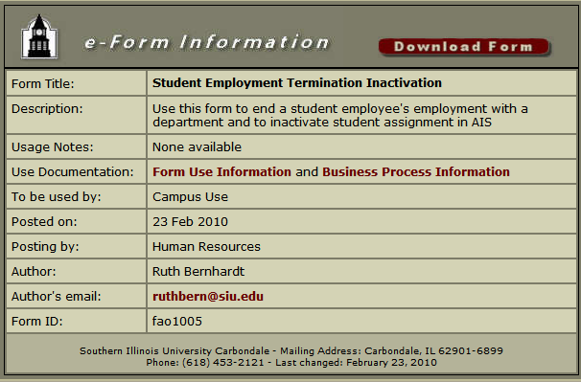
- A File Download dialogue box may display, based on the browser you are using. You will choose whether to Open the form or Save it to an internal or external source.
- If you Save the form, you’ll have to locate the file and open it. The filename is fac1005.pdf
- The STUDENT EMPLOYMENT TERMINATION/INACTIVATION form opens in Adobe .pdf, as shown below.
- You can now complete and submit the form according to the directions provided on the form.
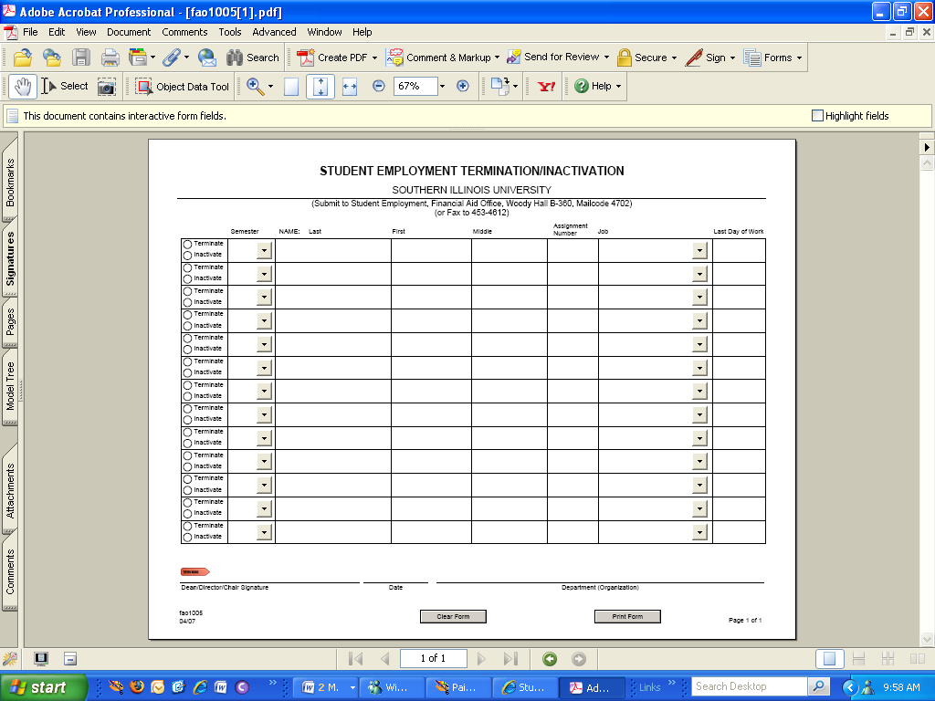
End of Document

